# Group 16 Project Details

## Discord

Server Invite Code (Doesn’t Expire) - qBkx5Mv

Please ensure to change your nickname in Discord to your real name, otherwise it is impossible for lecturers to tell who is who (this is very important as Discord screenshots are uploaded to the repository weekly).

## GitHub

After completing any tasks in JIRA, it is of critical importance to push this work to GitHub. This allows for any involved parties (from project managers to lecturers) to clearly link the work outlined in a JIRA task with a GitHub commit. Consequentially, it is also important to name your GitHub commit with a title that is easily identifiable. If you are performing a particularly large commit or may have committed multiple changes at once, you may also wish to briefly fill out the ‘description’ tab (see below).

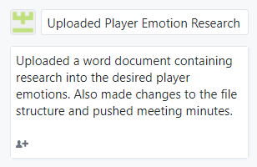

Figure 1 - An image demonstrating an example commit

The link for the group’s GitHub Repository can be found [here](https://github.com/UoSGroupProjects1819/mgp-team16).

## JIRA

JIRA can be accessed using the link below:

<http://jira.waterfrontgames.com:8080>

Please note that port number 8080 must be included at the end of the address or the JIRA board will not work.

## Unity

All Unity related work is to be completed in **Unity 2018.3.4** – it is highly important that this is the ONLY version of Unity that is used for the project to avoid any potential issues with upgrading the project to a newer version.

The Unity Download Archive can be accessed [here](https://unity3d.com/get-unity/download/archive) to ensure you are downloading the correct version.